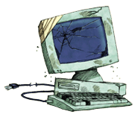

Phoenix Tech
Ashes to Life Computer Repair

Virus Removal, Upgrades, Tutoring
Satisfaction Guaranteed!

(732) 927-0320
www.thinkphoenixtech.com

